# ***Pattern Report Haotai Xiong – C00265675***

Used Pattern

* + Factory
  + Singleton

Factory - Purpose

The TowerFactory class serves as an abstract base for creating two types of towers. It defines a common interface for tower creation, which all specific tower factories will implement. This abstraction allows the game to instantiate towers without being coupled to the concrete classes of the towers.

Here below is the base class of tower.

Here below is the AoE Tower Inheritance class:   
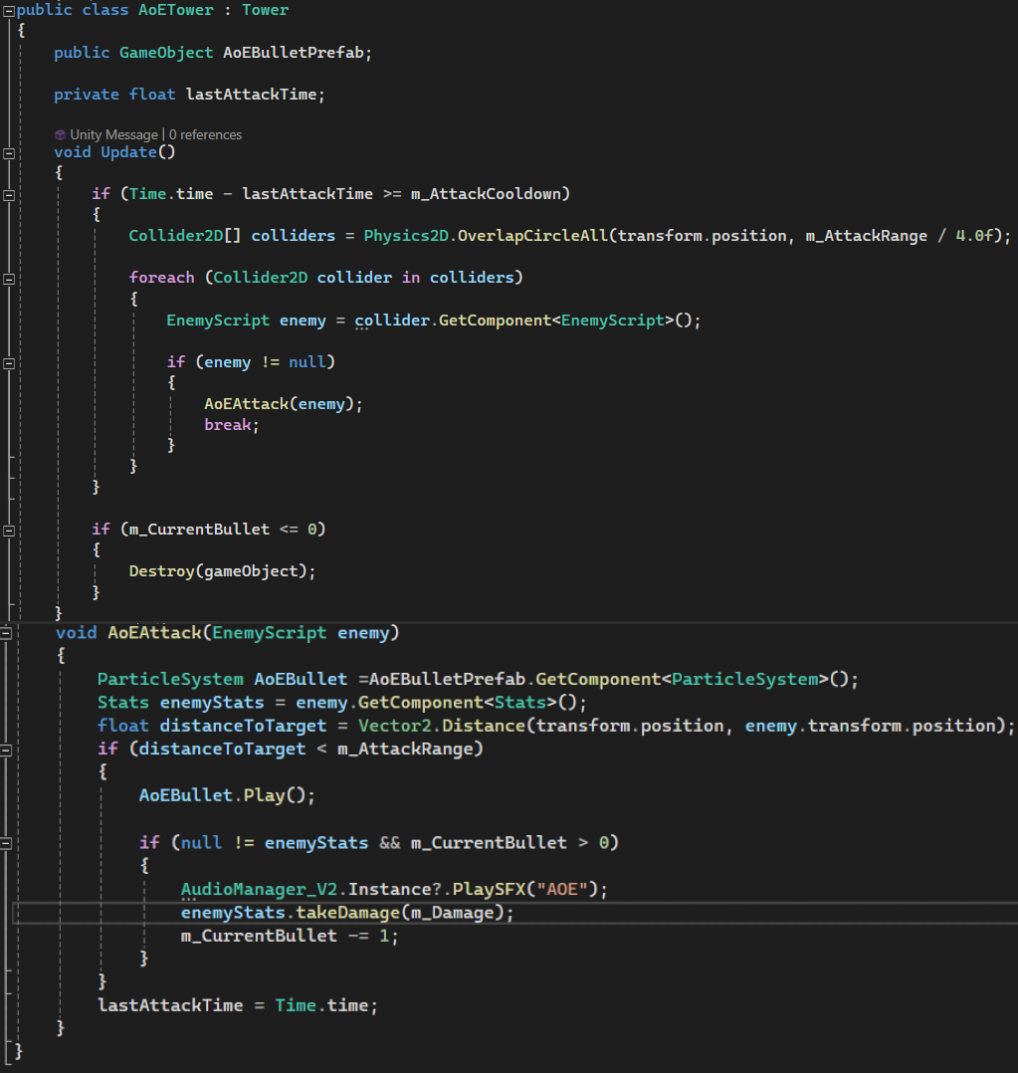

Here below is the Basic Tower Inheritance class:

Implementation of Factory Pattern

* Method: CreateTower(Vector2 position)
* Type: Abstract
* Description: Takes a position as a parameter and returns a Tower object. The specific implementation of this method will be provided by the concrete tower factories.

Concrete Tower Factory Classes

AoE Tower Factory

* Purpose: Handles the creation of AoE Towers. It extends the TowerFactory class and provides a specific implementation for creating an AoE Tower.
* Specialization: Initializes AoE Tower-specific properties such as AoEBulletPrefab.
* Functionality: Instantiates the AoE Tower prefab at a given position and initializes its unique properties.

Basic Tower Factory

* Purpose: Responsible for the creation of Basic Towers. It provides the concrete implementation required for instantiating a Basic Tower.
* Specialization: Sets up Basic Tower-specific elements, particularly the BulletPrefab.
* Functionality: Creates a Basic Tower instance and configures it with the necessary components.

Integration with Game Logic

* Functionality: Utilizes a TowerFactory to instantiate a tower. This method abstracts the process of tower creation, making the game code more modular and extensible.

Singleton - Purpose



Allow programmers to access and play any audio whenever they want.